Yakima Herald Republic June 30, 2023
Yakima Health District denies permits for two private landfills
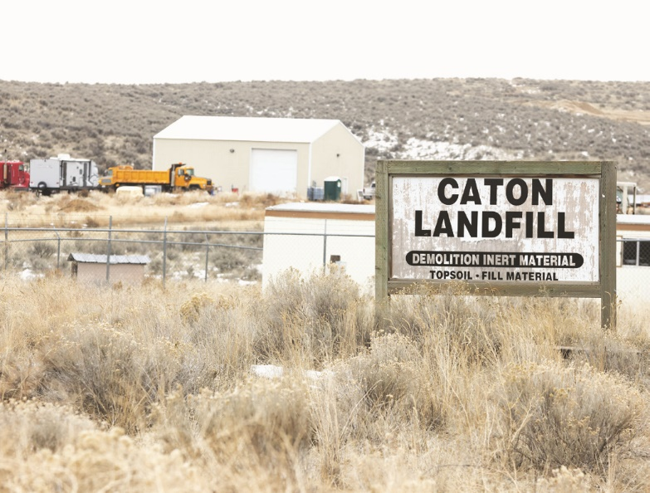
Caton Landfill is pictured Wednesday, Feb. 1, 2023, in Naches, Wash. Evan Abell / Yakima Herald-Republic

The Yakima Health District has denied permit renewals for two limited-purpose landfills at Rocky Top west of Yakima and near Naches.
The decision follows environmental concerns over the Caton Landfill near Naches and the DTG Recycle landfill at Rocky Top. Permits for both expire at the end of June.
While the details are different for each facility, the health district isn't renewing the permits because the operations are not in compliance with landfill requirements spelled out in state law, said Shawn Magee, the health district's director of environmental health.
"This is not meant to be a permanent shutdown," he said in an interview. "They are currently not in compliance, and we can’t allow operation while they are in noncompliance. There are too many issues that need to be worked out and solutions found and implemented for the landfills to operate within the regulations."
In December, the health district temporarily suspended a permit for the Caton Landfill near Naches following a series of fires. Regulators are monitoring air quality, groundwater and an underground fire at the DTG landfill at Rocky Top.
Limited-purpose landfills are designed to take manufacturing and construction waste such as concrete, glass, stainless steel, aluminum, lime, dirt and rock, wood waste, ash and other items.

Operations
The decision does not affect operations at DTG's material recovery facility at Rocky Top, which is permitted separately, Magee said.
In a statement to the Yakima Herald-Republic, the CEO of DTG Recycle, Tom Vaughn, said the company is committed to maintaining environmental compliance and has cooperated fully with all requests from the health district. The company acquired the facility at Rocky Top in 2019 and has invested in the landfill to "ensure and robust and responsible solid waste system."
"While we understand these decisions are complex, we are working diligently to provide the Health Department and Air Agency with any required information. Our objective is to work hand in hand with these regulatory bodies to ensure all environmental and health standards are not just met but exceeded," he said.
"We greatly appreciate the patience and understanding of our customers during this period. We assure you that we are doing everything possible to resolve the matter promptly and responsibly."
The Caton Landfill just has a permit for a limited-purpose landfill. A call and an email to company representatives were not immediately returned.

Working on issues
Magee said the health district has been working with the two landfills for a long time to address issues.
“There were goals set for these facilities and notifications given and simply put, they’re at their deadline. That’s why we took the action we did,” Magee said during a board of health meeting Wednesday.
He added that the denial of the permits was not an easy decision and he hopes continuing to work with the facilities will allow them to resume operations.
“I want to stress we don’t make these decisions lightly,” Magee said. “We’re still planning on working with them collaboratively and working on getting their permitting documents in order and getting operations updated and assist where we can in some of the other permits they need to obtain to gain compliance."
Magee said most of the waste being taken in by the two facilities comes from outside the county. For the small amount that comes from inside the county, Magee said the district is working to direct materials to the county-operated Terrace Heights and Cheyne landfills. While there are still some details to work out, he said the health district wants to make sure there was still a place to take local waste.
“We have coordinated with Yakima County to, in the interim, be able to accept some of those wastes from in-county waste producers,” Magee said. “Obviously those out-of-county will have to find other resources but we do have our in-county waste streams. We have resources for that.

Recent concerns
Fires were reported at the Caton Landfill at 1500 Naches-Wenas Road in December. The health district temporarily suspended Caton Landfill’s permit until the source of the fires was determined and a plan for how to prevent future fires was drafted. Officials also have raised questions about gravel mining at the site.
Residents near DTG's operations at Rocky Top have been concerned about truck traffic, odor, air quality, nighttime work and rock blasting. The health district is working with DTG, Ecology and the Yakima Regional Clean Air Agency to put out an underground fire at the landfill.
Joanna Markell contributed reporting.

