DIVE BRIEF

DTG Recycle CEO Vaughn steps down, founder takes on new role
The departure of longtime executive Tom Vaughn comes amid a period of acquisitions, layoffs and landfill investments for the Macquarie-backed company
Published Aug. 15, 2023
Cole Rosengren Lead Editor

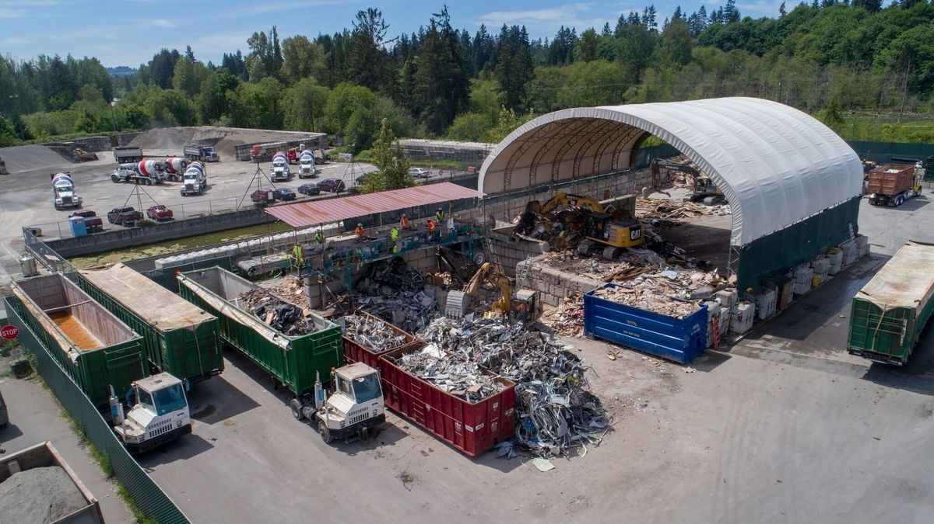
A DTG Recycle C&D facility Retrieved from Facebook on December 01, 2022

Dive Brief:
- Tom Vaughn recently stepped down as CEO of DTG Recycle, a Washington-based C&D recycling company.
- According to DTG, Vaughn left “to concentrate on his philanthropic environmental stewardship passions.” Vaughn had no further comment when reached Monday.
- An interim board management committee, chaired by longtime waste executive Kevin Walbridge, will now lead the company, according to private equity backer Macquarie. DTG founder Dan Guimont is now chief operating officer.

Dive Insight:
DTG, which Guimont founded in 1999, has expanded rapidly in the broader Puget Sound area through multiple acquisitions and rounds of private equity investment. This latest development comes amid an eventful period for the company, which describes itself as a leading C&D recycler in the Pacific Northwest.
Last December, a Macquarie Asset Management fund acquired DTG and Clairvest Group exited a minority position in the company. Guimont then was named chief development officer, after previously serving as president, with he and Vaughn retaining ownership stakes in the company. At the time, DTG reported having more than 500 employees.
Then, in January, DTG acquired three companies — Clayton-Ward Co., KT Recycling & Container and United Recycling — which also expanded its footprint into Oregon. According to multiple sources, DTG has since laid off more than 200 people in various parts of the business to optimize operations following a period of rapid growth.
Layoffs also extended to the company’s sole disposal location, the Anderson Landfill in Yakima, Washington, after the local health district denied the renewal of its operating permit for multiple reasons. The company is currently working with state and local regulators on compliance and to mitigate an ongoing subsurface fire at the location. Looking ahead, DTG also plans to add a liner at the unlined site and expand its footprint. Last month, a DTG representative said the company hoped to reopen the landfill by Q3 2024.
According to a 2020 profile in Construction & Demolition Recycling, DTG got its start when Guimont acquired a C&D recycling operation from Vaughn to complement his own hauling business. About a year after the deal, Guimont asked Vaughn to join DTG in a leadership role. During Vaughn’s tenure, DTG completed numerous acquisitions and launched multiple recycling facilities.
“DTG thanks Tom for his loyal years of service and commitment to the environment while building the DTG brand and expanding markets for recyclable materials,” said a company spokesperson via email.
This marks the latest in a series of leadership changes at Macquarie-backed waste companies during 2023. Illinois-based LRS recently announced a new CEO and CFO, following the departure of prior leaders in the spring. Last month, New Hampshire-based WIN Waste Innovations also reset its three top leadership roles.

